AEM TASK – 8

# MSM, Blueprint, Live Copy, and Rollout

* **MSM (Multi-Site Manager)**: AEM’s MSM feature allows users to manage multiple sites efficiently by creating and maintaining relationships between similar content across different locales or variations.
* **Blueprint**: A blueprint is a master version of a site or page that serves as a source for live copies. Changes made in the blueprint can be rolled out to live copies.
* **Live Copy**: A live copy is a child version of a blueprint page/site that inherits content and structure from the blueprint. Updates from the blueprint can be rolled out to the live copy.
* **Rollout**: Rollout is the process of pushing updates from a blueprint to its live copies, ensuring content synchronization.

# Language Copy

A language copy in AEM is a duplicate of an existing site in a different language. It is commonly used in global websites to manage localized content. Unlike MSM live copies, language copies do not maintain a relationship with the source, meaning changes in the source page do not automatically reflect in the language copy.

# Creating a Site Using MSM with us/en as the Source Steps to Create an MSM-Based Site

1. **Created the Blueprint Site**: Defined the master structure that served as the source for live copies.
2. **Created a Live Copy**: Generated a linked version of the blueprint in a different location to maintain content consistency.
3. **Rolled Out Changes**: Updated the live copy whenever the blueprint changed to ensure synchronization.

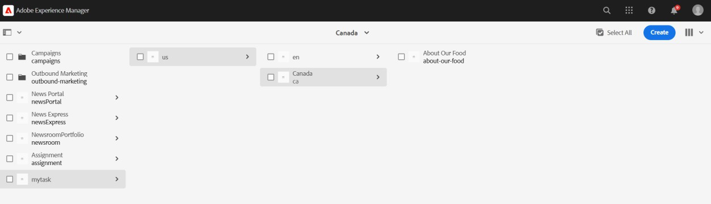

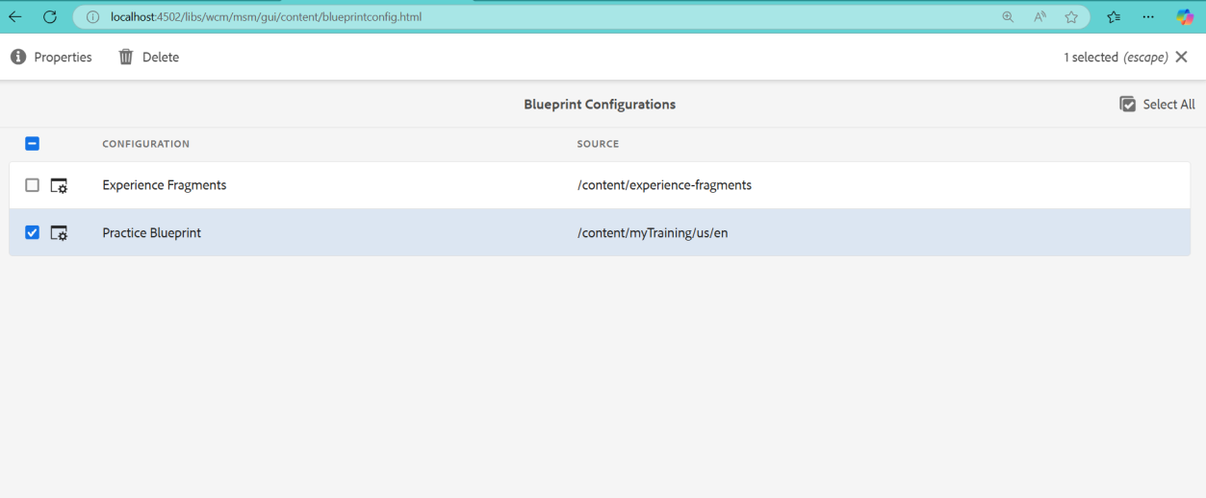

# Creating the McDonald's ‘About Our Food’ Page in AEM Steps to Author the Page in AEM

1. **Created a Page**: Used AEM’s page creation feature to develop the required page structure.
2. **Added Components**: Included necessary components such as images, text, and buttons to replicate the reference page.
3. **Published the Page**: Made the page live and accessible within AEM

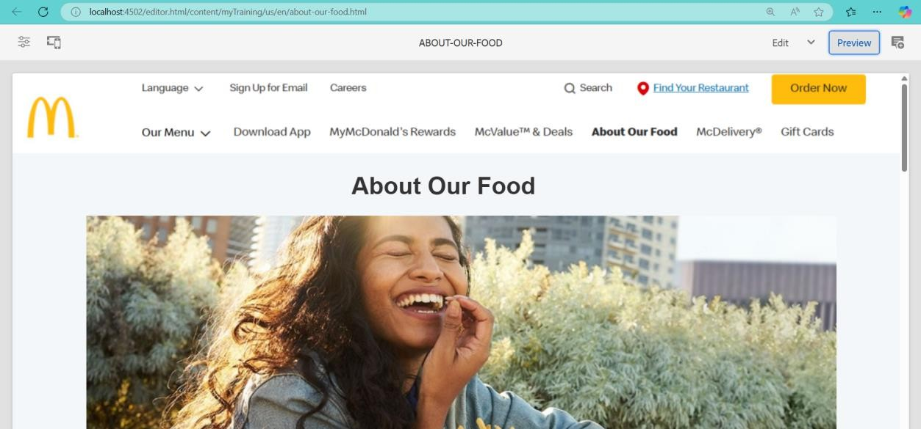

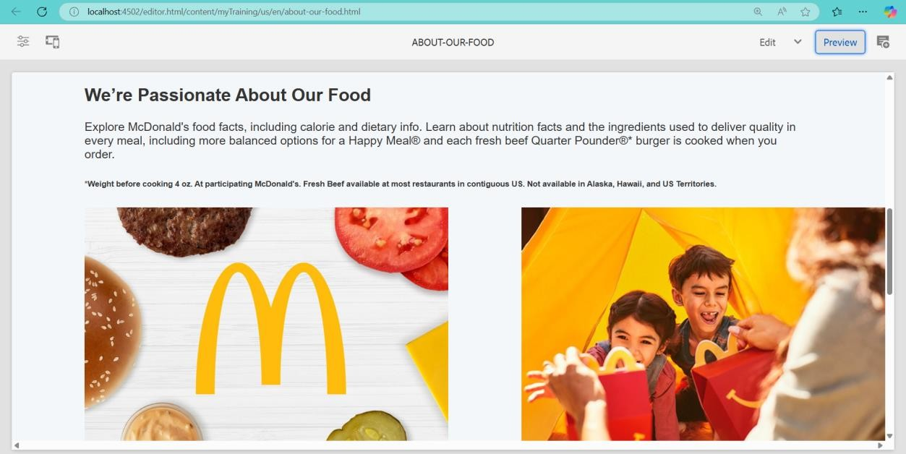

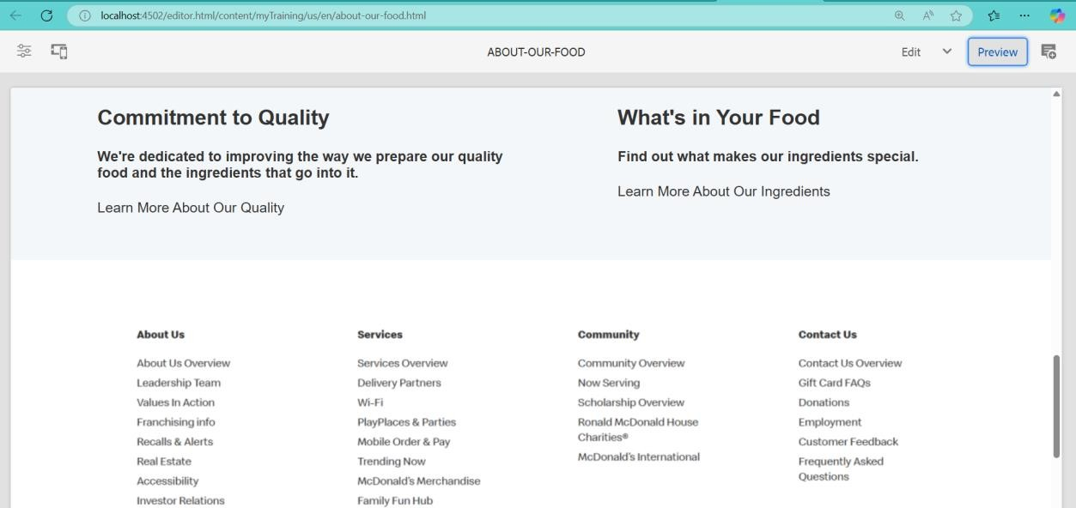

# Setting Up AEM Dispatcher Locally

1. Ensured the necessary software and configurations were available before setup.
2. Acquired the required dispatcher module for integration with Apache.
3. Adjusted necessary settings to route traffic through the dispatcher.
4. Finalized setup by restarting services and testing the configuration.

